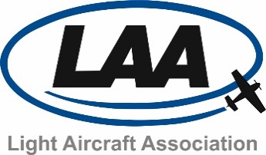

Annex 4 – Exhibitor Booking Form

Company Details
Company Name:

Invoice Address:

Contact Name:

Contact Telephone Number:

Email Address:

Website Address:

Booking Details : Plot Numbers
Outside Space:
Chalet:
Do you require electricity? Yes No
Outside exhibitors requiring electricity should contact the Light Aircraft Association for availability or for use of your own small generator which may be acceptable.
Confirmation
I confirm that I have read and accepted the LAA Exhibitor Terms and Conditions.
Your booking will not be confirmed nor guaranteed until full payment has been received.
Name:

Signature: Date:

Office Use Only:

